16x16 Signed and Unsigned Multiplier Design Specifications

Aamir Alam Farooqui

C/o

Prof. Vojin G. Oklobdzija

Booth Encoder
Booth encoder is the basic building block of the 16x16-multiplier unit. This encoder scans three overlapped bits of the 16-bit multiplier and depending on these three input bits, it produces four outputs (x1, x2, x-1, x-2, where x1 means multiply by 1, x-2 means multiply by –2 etc.) as shown in Table-1 below. The logic diagram of this multiplier is shown in Figure-1.

a_{i+1} | a_{i} | a_{i-1} | Encoder Output
0 | 0 | 0 | 0
0 | 0 | 1 | x1
0 | 1 | 0 | x1
0 | 1 | 1 | x2
1 | 0 | 0 | x-2
1 | 0 | 1 | x-1
1 | 1 | 0 | x-1
1 | 1 | 1 | 0

Table – 1
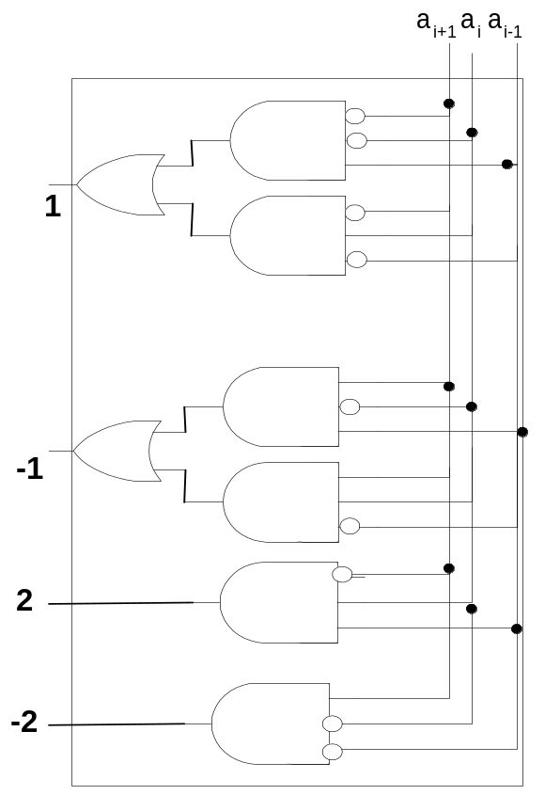For 16-bits eight such encoders are required. The bits a_{i+1}, a_{i}, and a_{i-1}, represents the three bits of the multiplier. For the first encoder a_{i-1} is 0, and for all the other encoders it is the overlapped bit with the previous encoder.

Figure-1 Booth encoder

Booth Selector
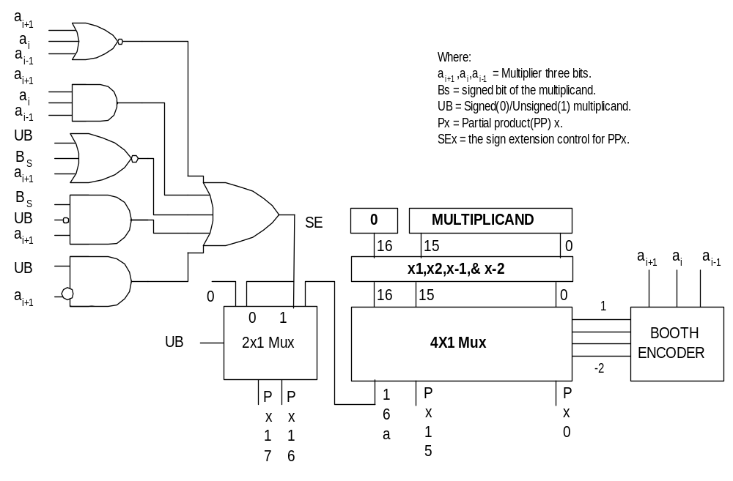The 16-bit multiplier is applied to eight booth encoders and the 16-bit multiplicand is applied to eight booth selectors. Booth encoders control the outputs of the booth selectors. Each booth selector produces 18-bit partial product. The booth selector is composed of hardwired shifters, multiplexer, and the sign extension correction circuit as shown in Figure 2.

Figure-2 Booth Selector and Encoder

Each booth selector produces multiplicand times 1, 2, -1, or –2 depending on the output of the booth encoder. The most significant bit of the Booth selector is used for controlling the sign extension. The partial products generated by the Booth selector are then added using TDM.

Sign Extension Prevention
When adding partial products using CSA (carry save adders) each partial product must be sign extended to the most significant binary position. The addition of these extended signs becomes very costly. In order to prevent that following technique has been used. In this technique it is supposed that the partial products are negative. Therefore the sign of all the sign extensions can be pre-calculated as a constant number = 101010…01011. This constant number is finally added to the partial products. The addition of the constant factor is dependent on UB (Signed (0)/Unsigned (1) multiplicand as shown in Table-2). If it turns out that a partial product is positive then the sign extension control bit (SE) = 1. The SE is dependent on Bs (sign bit of the multiplicand), a_{i+1,} a_{i,} a_{i-1,} and UB. The SE is calculated according to Table-3.

UB | Constant Factor
0 | Add Const. Factor
1 | Add 2xConst. Factor

Table-2

a_{i+1} | Bs | UB | SE
0 | 0 | 0 | 1
0 | 0 | 1 | 1
0 | 1 | 0 | 0
0 | 1 | 1 | 1
1 | 0 | 0 | 0
1 | 0 | 1 | 0
1 | 1 | 0 | 1
1 | 1 | 1 | 0
a_{i+1} | a_{i} | a_{i-1} | SE
1 | 1 | 1 | 1
0 | 0 | 0 | 1

Table-3

Bit # 17 & Bit # 18 logic
Bit # 17 and 18 are used for controlling the sign extension correction. Bit 17 is used when the multiplicand is a signed number (signal UB is zero) and bit 18 is used when the multiplicand is unsigned (signal UB is 1). From Table-3 it is clear that bit # 17 is one when, UB=0 AND (a_{i+1} Xnor Bs) for signed multiplicand. Similarly bit #18 is one when a_{i+1} = 0 AND UB = 1, these conditions show that the partial product is positive and one must be added to the result to correct the previous assumption of all negative PP’s. The Sign extension bit SE is ONE when multiplied by zero i.e., a_{i+1,} a_{i+1,} and a_{i+1} = 111 or 000.

Bit # 18 is used when the multiplicand is unsigned. When the Multiplier is unsigned and the most significant bit of the multiplier is one (i.e., bit # 16 AND UA) then Multiplicand is added with the 8-Partial products. Like the ninth Partial Product.

TDM
Three Dimensional Reduction Method (TDM) is an algorithm for the generation of a parallel multiplier, which is optimized, for speed. The basic idea behind this method is to make proper connections globally so that the delay throughout each path is approximately the same. The long delay path originating from previous adder should be connected to the short delay path of the next one, and so on. It is possible to apply this idea to the partial product array using full adders. Since all of the partial products bits in the same bit position are logically the same and therefore interchangeable and the carry signal of the full adder is generated earlier (1 Xor) than the sum signal. The Interconnection of all the partial products and adders using TDM is shown in Appendix-1. Figure-3 below shows the overview (Figure-4 shows the detailed overview) of the multiplier.

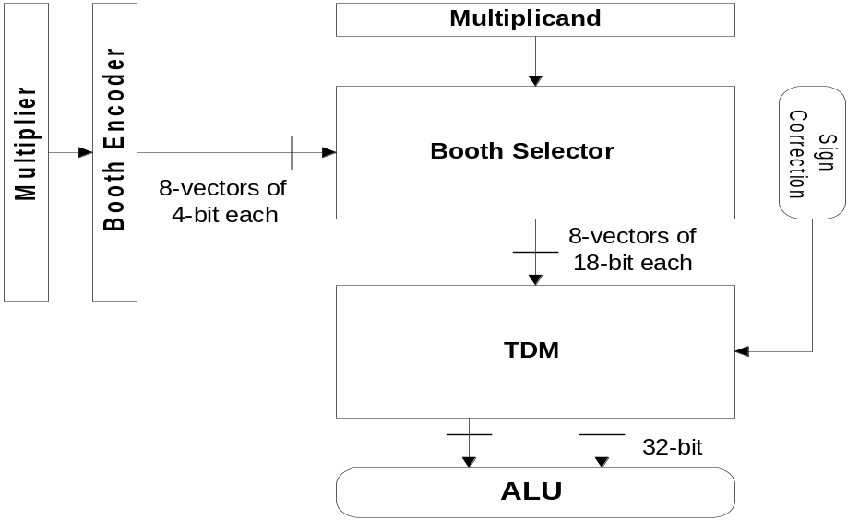Figure-3 16 x 16 Signed / Unsigned Multiplier

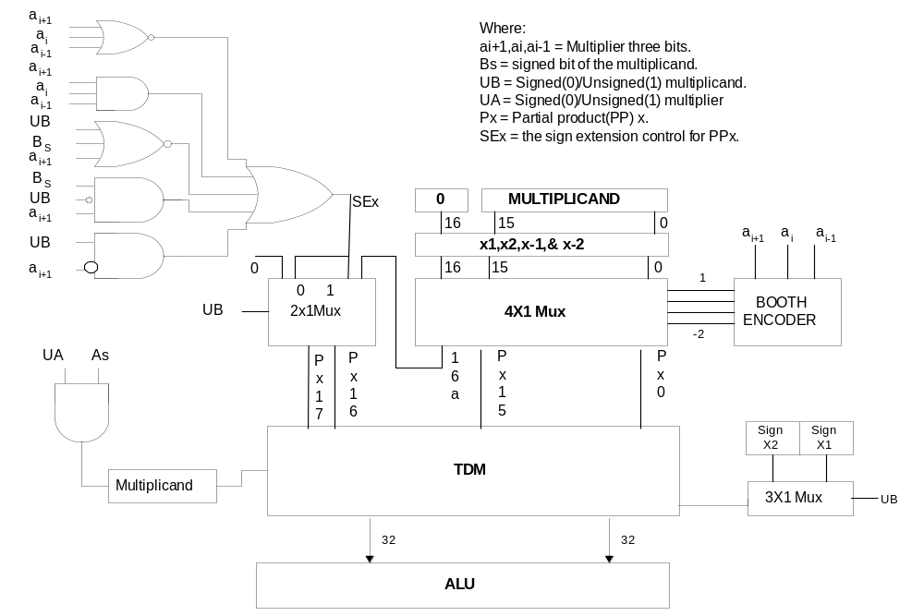

Figure-4 Detailed overview of the Multiplier

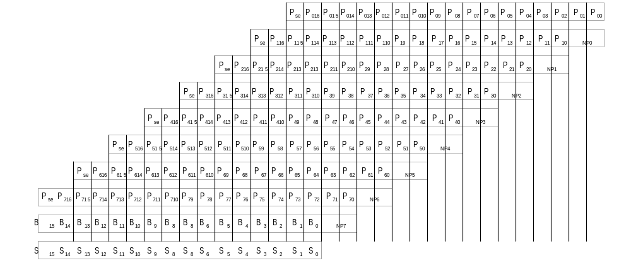Figure-5 Partial Products bit position.

